**Review Worksheet Answers: Protein/Amine/Peptide vs Steroid Hormones**

1: For each of the following pieces of information, circle whether they apply to amine hormones or steroid hormones.

(0.5 marks per correct answer – 9 marks total)

|  |  |
| --- | --- |
| **Information** | **Answer** |
| Binds to receptor on cell membrane | Amine / Steroid |
| Lipid (fat) soluble | Amine / Steroid |
| Activates genes to produce an enzyme or structural protein | Amine / Steroid |
| Shorter duration of action | Amine / Steroid |
| Aldosterone | Amine / Steroid |
| Triggers release of a second messenger | Amine / Steroid |
| Binds to receptor on nucleus or other organelles | Amine / Steroid |
| Changes shape of enzyme to turn it “on” or “off” | Amine / Steroid |
| Sex hormones such as Testosterone, Oestrogen and Progesterone | Amine / Steroid |
| Growth Hormone | Amine / Steroid |
| Water soluble | Amine / Steroid |
| Longer duration of action | Amine / Steroid |
| Cortisol | Amine / Steroid |
| Changes rate of transcription and translation to control rate of protein production | Amine / Steroid |
| Second messenger activates and amplifies enzymes that change cell functioning | Amine / Steroid |
| Passes through cell membrane | Amine / Steroid |
| Thyroxine | Amine / Steroid |
| Insulin | Amine / Steroid |

2: Briefly describe what happens during the process of enzyme amplification.

(3 marks)

*The hormone triggers a cascade of chemical reactions (1) where the number of molecules increases exponentially (1) at each step. This results in the production of billions of enzyme molecules from one hormone molecule (1).*

3: Look at the diagram below and then complete the questions below.

(11 marks)

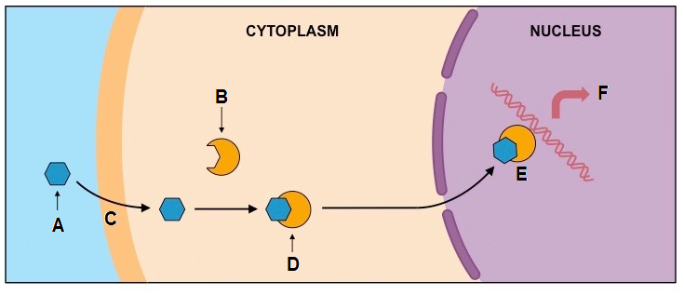

Is this an example of the mode of action for an amine hormone or a steroid hormone?

*Steroid*

Label structures / substances: (2)

A: *Hormone*

B: *Receptor (specific for that hormone)*

Describe what is happening at the following points: (6)

C: *The hormone passes through the cell membrane as it is lipid soluble.*

D: *Hormone binds to receptor forming a hormone-receptor complex*

E: *Hormone receptor complex binds to DNA*

What processes could happen at F, in response to E? (3)

*After the hormone receptor complex binds to the DNA, it may:*

* *Activate genes to produce an enzyme or structural protein*
* *Change the shape of an enzyme to turn it “on” or “off”*
* *Change the rate of transcription and translation to control rate of protein production.*

4: Look at the diagram and complete the questions below:

(10 marks total)

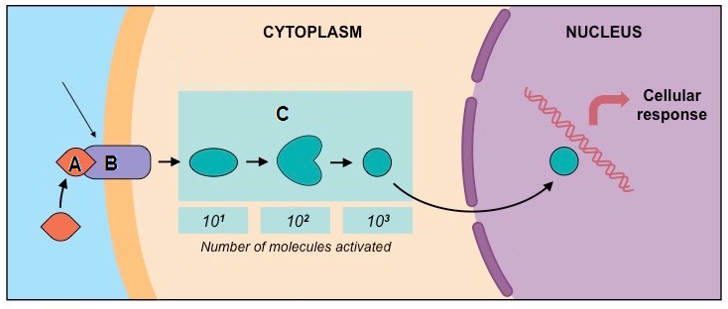

Is this an example of action of an amine hormone, or a steroid hormone? (1)

*Amine hormone*

Label structures: (2)

A: *Hormone*

B: *Specific receptor for that hormone*

Why does A need to bind to B at this location? (2)

*A is an amine hormone and is not lipid soluble (1), so cannot pass through the cell membrane. It must therefore bind to a surface receptor (1).*

What is released as a result of A binding to B? (1)

*A second messenger (1)*

Describe what is occurring during process C*. (4)

*Enzyme amplification is occurring (1). During this process the hormone binding to the receptor site triggers a cascade of chemical reactions (1) where the number of molecules increases exponentially (1). This means that one hormone molecule can trigger production of billions of enzyme molecules.(1)*